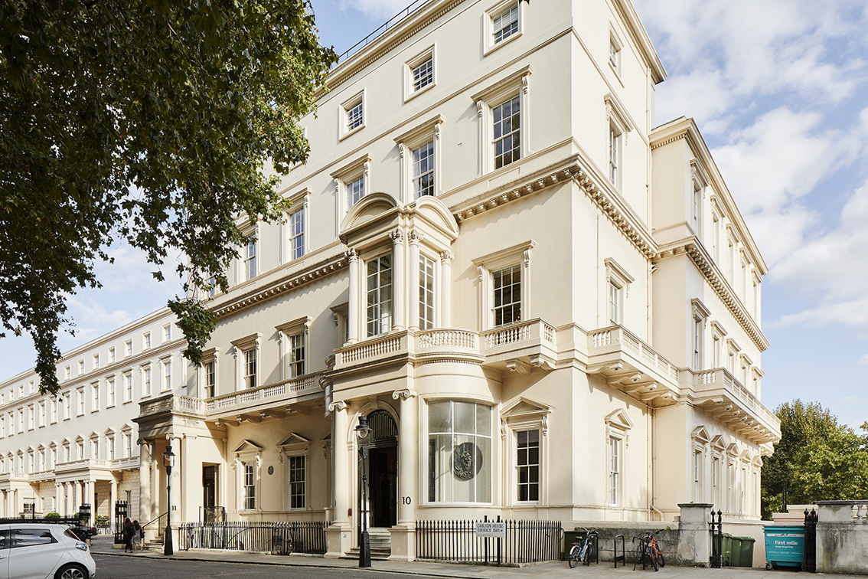
Historic British Academy transformed: Sennheiser audio meets Georgian elegance
Combining heritage and modern technology for world-class events and collaboration

London, UK, January 2025 – The British Academy, the UK’s national academy for humanities and social sciences, has completed a remarkable transformation of its historic headquarters at 10 and 11 Carlton House Terrace in London. This ambitious renovation combines 1830s Georgian splendour with state-of-the-art audio-visual systems to create versatile spaces for events, performances, and meetings. At the core of this transformation lies Sennheiser’s audio technology, delivering impeccable sound quality and speech intelligibility while preserving the building’s historic charm.

The British Academy has occupied Carlton House Terrace since 1998, expanding into number 11 in 2010. A renovation in 2011 connected the two buildings, paving the way for the latest refurbishment, which began in late 2021. The multi-phased project included reimagining the lower ground floor, as well as upgrading the ground and upper levels.

Ross Watson, AV Manager at the British Academy, played a crucial role in aligning the technical objectives with the historic nature of the building. “When I visited Sennheiser’s UK base to meet with Inesh [Patel, Business Development Manager, BizCom at Sennheiser], I saw how the TeamConnect Ceiling (TCC) microphones seamlessly covered large spaces. That’s exactly what I envisioned for the British Academy: a discreet system that would deliver high-quality audio while blending into the building’s historic interiors,” he explains.

Following this meeting, Patel, accompanied by Sennheiser colleague Joe Mahoney, demonstrated the TeamConnect Ceiling 2 (TCC 2) system in the Music Room - a challenging acoustic environment originally designed for musical performances.

“I had so much confidence in a successful outcome that I decided to use the Music Room to demonstrate the TCC 2,” says Patel. “I figured, let’s test it in the most challenging space. When Ross reported back that the people on the other end of the Teams call could understand the conversation better than the people in the room, I knew we had closed the deal.”

A Lower Ground Floor transformation
The lower ground floor has been reimagined into three versatile event spaces: the Wohl Gallery, the SHAPE Room, and the Lecture Room. Previously a labyrinth of pre-war corridors and rooms, the new spaces are equipped with advanced AV solutions, offering unparalleled flexibility for performances, exhibitions, and conferences.

All three lower ground floor spaces at the British Academy are equipped with Sennheiser’s TCC 2 microphone arrays, MobileConnect systems, and SpeechLine Digital Wireless microphones. Pictured here is the Whol Gallery. Image © The British Academy. | 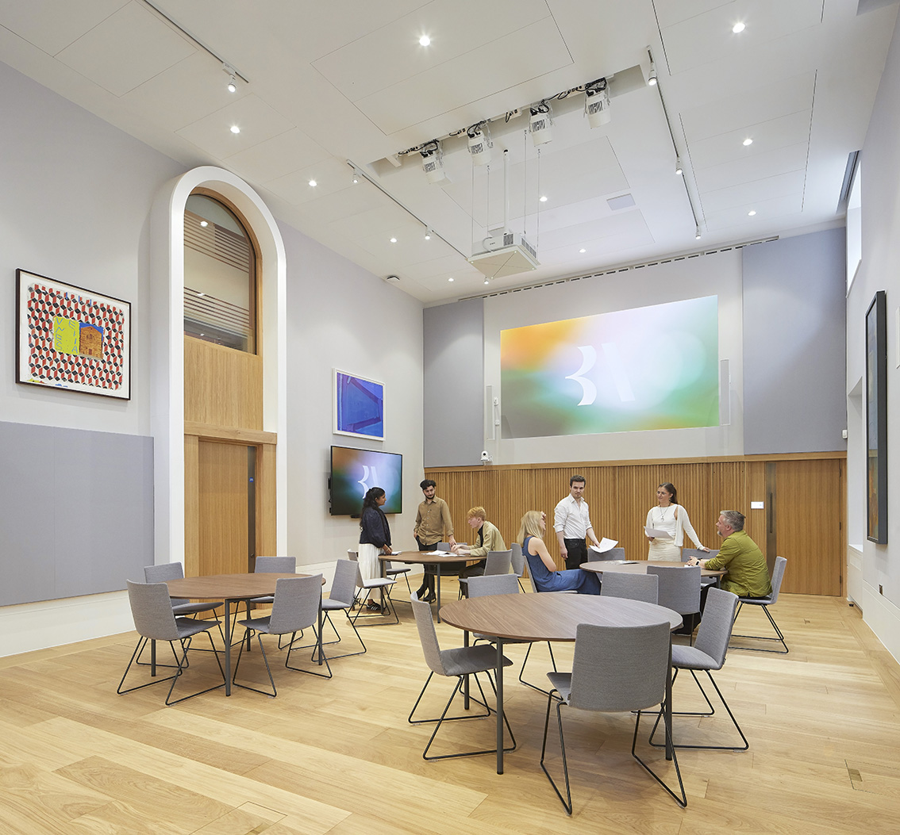

Paul Marshall of Recursive, who spearheaded the AV design, explains the evolution of the project: “The idea started with blank white-box rooms that clients could customise as needed. However, we quickly realised the limitations of that approach—particularly the challenge of providing high-quality AV setups without constant reliance on external equipment. That’s when we pivoted to designing three fully equipped, unique spaces that could adapt quickly to various needs.”

To ensure seamless integration with the historic design, Recursive collaborated closely with Wright & Wright Architects. “Their expertise in heritage buildings ensured that nothing looked out of place, even with the significant technical upgrades,” Marshall adds.

All three spaces feature Sennheiser’s TCC 2 microphone arrays, MobileConnect systems, and SpeechLine Digital Wireless microphones. Marshall explains the reasoning behind these choices: “We’d used Sennheiser’s TCC 2 in similar heritage buildings nearby and knew they’d provide the coverage we needed without compromising aesthetics. The automatic adaptive beamforming technology with TruVoicelift functionality ensures clear audio for Q&A sessions or presentations without requiring visible microphones, which would disrupt the room’s design.”

MobileConnect, Sennheiser’s IP-based bi-directional communication solution, provides a practical alternative to induction loops, which were unsuitable due to the solid wooden floors. “MobileConnect provides a future-proof solution for hearing assistance and other uses, like streaming audio across the spaces. Everything is IP-based and connected via Dante, allowing us to route audio anywhere in the building with ease,” Marshall notes.

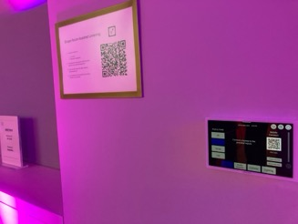 | MobileConnect, Sennheiser’s IP-based bi-directional communication solution, provides a practical alternative to induction loops, which were unsuitable due to the solid wooden floors

Marshall highlights the design approach: “These spaces were built to adapt quickly to diverse needs, ensuring intuitive technology without compromising the building’s heritage.” Overseeing the three rooms is a mezzanine-level control room that uses Sennheiser Control Cockpit software to monitor and manage microphones and other systems. Mike Breen, Head of Systems Integration division at Media Powerhouse adds, “From quad projection to Sennheiser’s TCC 2 microphones, every detail enhances the user experience, showcasing what modern technology can achieve in a heritage space.”

Ground Floor and Upper-Level Rooms
On the ground and upper floors, CSL Integration seamlessly blended cutting-edge AV technology with the British Academy’s historic interiors. David Dempsey from CSL Integration describes the significance of the project: “The British Academy sits at the crossroads of corporate, educational, and event environments, which makes it quite special. Integrating advanced AV solutions into these spaces while preserving their historical elegance was a key focus for us.”

On the ground and upper floors, CSL Integration seamlessly blended cutting-edge AV technology with the British Academy’s historic interiors | 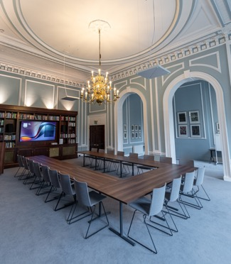

The Reading Room, once the dining hall of four-time Prime Minister William Gladstone, now serves as a multi-purpose venue with sweeping views of The Mall and St. James’s Park. Equipped with Sennheiser’s TCC 2 microphones, SpeechLine Digital Wireless systems, and Q-SYS systems, the room supports versatile functionality for presentations, lectures, and events.
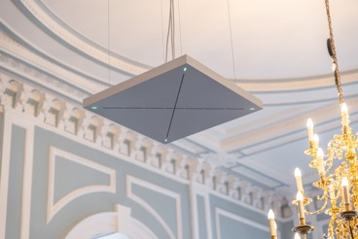 | Equipped with Sennheiser’s TCC 2 microphones, SpeechLine Digital Wireless systems, and Q-SYS systems, The Reading Room supports versatile functionality for presentations, lectures, and events

The Library, another elegant space on the ground floor, has been equipped with a similar AV setup, ensuring accessibility and ease of use. Dempsey highlights the challenges of working in a Grade I listed building: “We couldn’t make alterations to walls or ceilings, so the in-house team lifted the flooring from above to install the cables without causing damage. Their expertise was invaluable in maintaining the building’s integrity.”

The high-ceilinged Library, with period decoration, incorporates TCC 2 microphones that blend in seamlessly into the room. Image © The British Academy. | 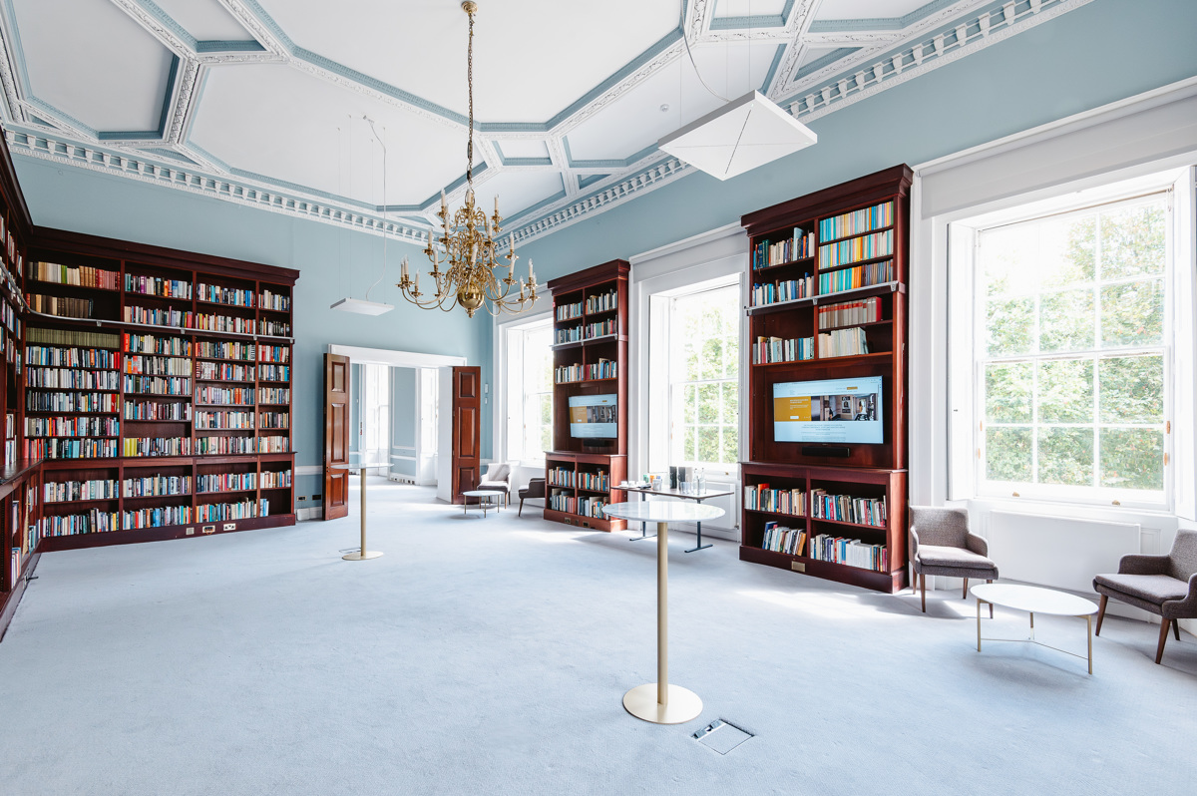

On the upper floors, meeting rooms such as the Helen Langan Room were outfitted with Sennheiser’s TeamConnect Ceiling Medium (TCC M) microphones, Logitech Tap touchscreens, and SpeechLine Digital Wireless systems. These smaller boardroom-style spaces provide seamless audio and video conferencing capabilities for up to 12 people.
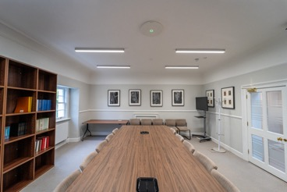 | Equipped with Sennheiser’s TCC 2 microphones, SpeechLine Digital Wireless systems, and Q-SYS systems, The Reading Room supports versatile functionality for presentations, lectures, and events

“When CSL started out 20 years ago, systems like these didn’t exist,” reflects Dempsey. “Video conferencing was a luxury then. Today, technology like Sennheiser’s automatic dynamic beamforming and TruVoicelift offer you perfect speech intelligibility and maximum freedom of movement, especially in spaces with unique challenges like these.”

Blending heritage with innovation for future generations
The successful refurbishment of the British Academy demonstrates how thoughtful AV design can elevate historic spaces. From technologically advanced event spaces on the lower ground floor to seamlessly integrated meeting rooms on the upper levels, the project preserves the building’s heritage while enabling its modern functionality.

Reflecting on the project, Patel shares: “Working on a project of this scale and significance is a privilege. It’s a testament to what can be achieved when teams collaborate, combining technical expertise with respect for heritage. At Sennheiser, we’re proud to support iconic institutions like the British Academy, ensuring their historic spaces remain relevant and functional for future generations.”

Marshall echoes the sentiment: “This project was all about collaboration. From the architects who preserved the building’s heritage to the integrators who brought the technology to life, everyone worked together to create spaces that are both functional and beautiful.”

“The effort behind this transformation was monumental,” agrees Breen. “From AV-over-IP to beamforming microphones, the technology is cutting-edge, but it’s the collaboration between all stakeholders that made this project so successful. When you have a team that’s willing to share knowledge and solve challenges together, the results speak for themselves. The lower ground floor is now a modern masterpiece, ready to host anything from academic conferences to artistic showcases.”

Dempsey concludes: “The multifunctional nature of the British Academy makes these spaces truly special. When visitors experience the AV systems here, they’ll leave inspired - and likely questioning why their own facilities aren’t as innovative.”

(Ends)

The high-resolution images accompanying this media release can be downloaded here.

About the Sennheiser brand
We live and breathe audio. We are driven by the passion to create audio solutions that make a difference. Building the future of audio and bringing remarkable sound experiences to our customers – this is what the Sennheiser brand has represented for more than 75 years. While professional audio solutions such as microphones, meeting solutions, streaming technologies and monitoring systems are part of the business of Sennheiser electronic SE & Co. KG, the business with consumer devices such as headphones, soundbars and speech-enhanced hearables is operated by Sonova Holding AG under the license of Sennheiser.

www.sennheiser.com
www.sennheiser-hearing.com

Global Bizcom Press Contact
Jeffrey Horan
Jeffrey.Horan@sennheiser.com
+18605987539

